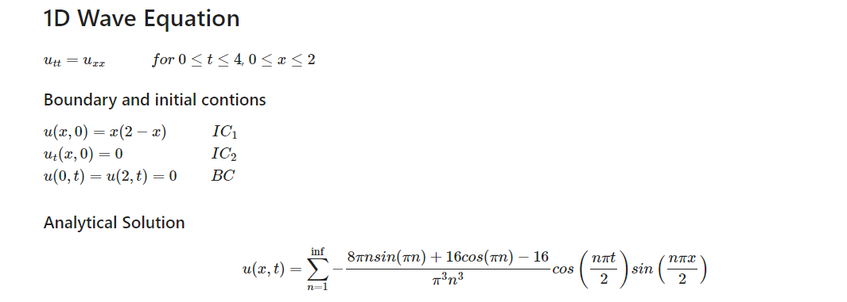

* ***Domain :***

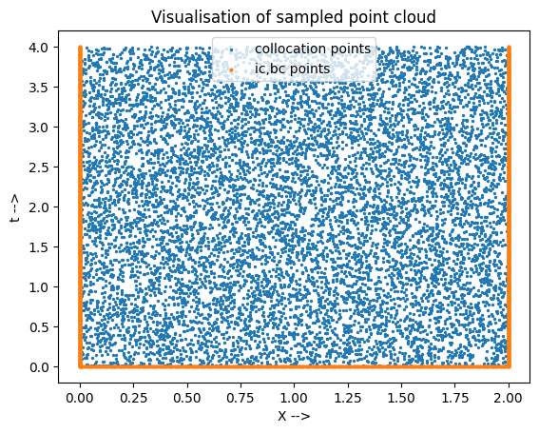

N_f (collocation points) = 10000

N_u(points sampled from BC,IC) = 1000

Points are sampled using Latin hypercube sampling.

* ***Loss Function formulation:***

1. ICBC Loss = $\frac{1}{Nb}$ $\sum_{i=0}^{Nb}{{\left(\hat{y}-y\right)}^{2}}$ + $\frac{1}{Ni}\sum_{i=0}^{Ni}{{{\left(\frac{∂u}{∂t}\right)}_{x=0}^{2}}^{}}$

Where Nb = No. of boundary points , Ni = No. of initial condition points

1. PDE Loss = $\frac{1}{N}\sum_{i=0}^{N}{{\left(\frac{∂^{2}u}{∂t^{2}}-\frac{∂^{2}u}{∂x^{2}}\right)}^{2}}$

Where N = N_f + N_u

* ***Activation function used:*** tanh()
* ***RESULTS:***

|  |  |  |  |
| --- | --- | --- | --- |
| **Layers** | **Neurons** | **Residual loss** | **Epochs** |
| 4 | 20 | 8.995484e-05 | 2500 |
| 4 | 30 | 3.890816e-05 | 2500 |
| 4 | 40 | 3.214692e-05 | 2500 |
| 4 | 50 | 2.465390e-05 | 2500 |
| 4 | 60 | 1.937172e-05 | 2500 |

* **Comparison of PINNS results from analytical results at particular Time:**

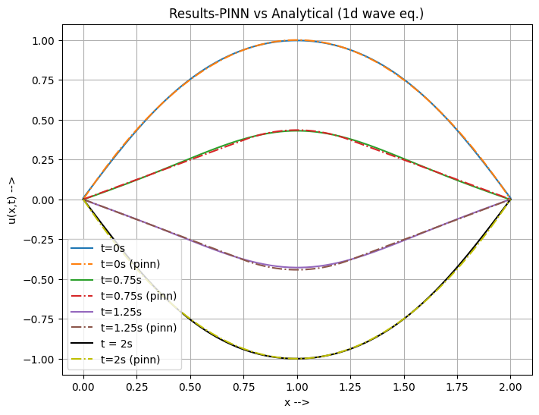

* **Loss convergence**: Loss is plotted in logarithmic scale.

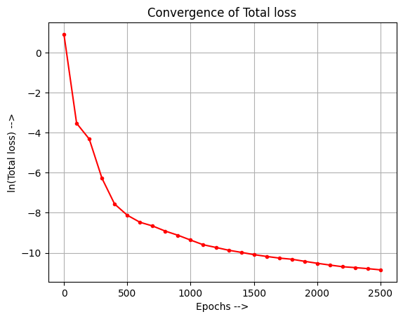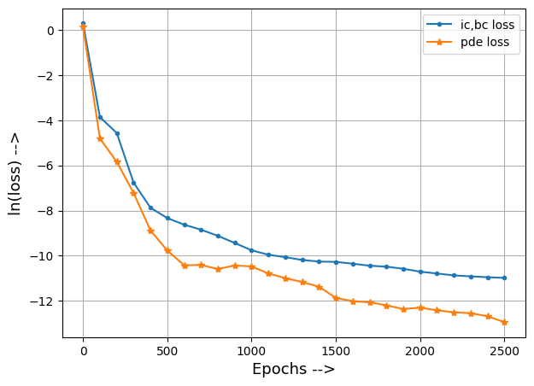

* **Contour plot (PINN solution):**

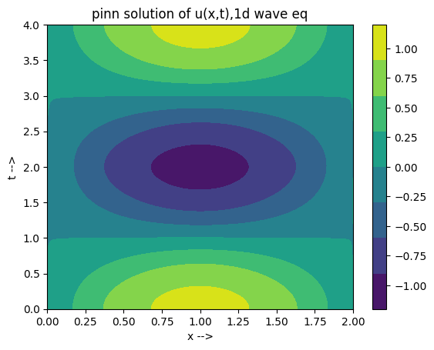

* **Contour plot (Analytical solution):**

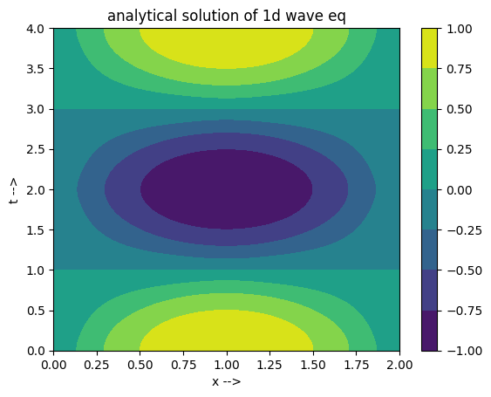

* **Error between Analytical solution and PINN solution:**

